# Link Replacer/DNA Tool

## Introduction

Link Replacer/DNA Tool (from now on simply referred to as “the program”) is an application written in C#. It was designed to bulk manipulate PDFs to relieve the user of performing menial, repetitive tasks and to reduce user error.

## Interface

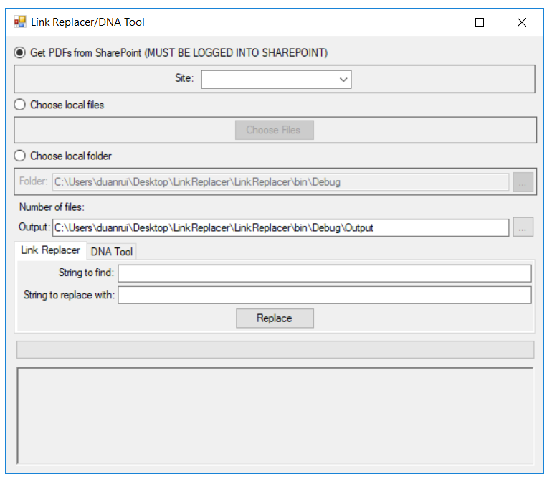

8

7

6

5

4

1

2

3

1. **Get PDFs from SharePoint** (Checked by default): Directly grabs the PDFs from the specific SharePoint site.
2. **Choose local files**: Manually pick file(s) from a file browser dialog, multiple file selection is supported.
3. **Choose local folder**: Grabs all the PDFs in the selected folder. Can either paste the file path directly in the textbox or open the folder browser dialog by pressing the “…” button next to the textbox.
4. **Number of files**: Displays the number of files selected/found in the folder/SharePoint. IMPORTANT – If there is no number after selecting files/folder/SharePoint, something has gone horribly wrong.
5. **Output folder**: Choose where the program places the PDFs/CSV file. Can either paste the file path directly in the textbox or open the folder browser dialog by pressing the “…” button next to the textbox. If the specified path does not exist, the folder will be automatically created.
6. **Link Replacer/DNA Tool tab**: Switch between tools by clicking on the respective tab. More detail below.
7. **Progress bar**: Displays current progress.
8. **Text log**: Displays the current file being read and any warnings/errors that occur.

**IMPORTANT – Search through the text log for “ERROR” messages after the program finishes running to find problematic files.**

## Link Replacer

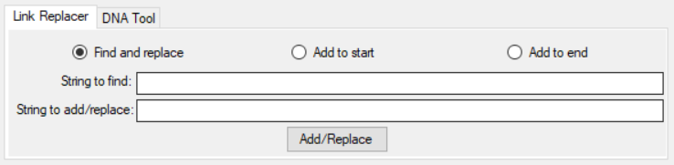

The Link Replacer tool can either act as a find-replace-all tool or add strings to the start or end of hyperlinks that contain the search string.

### Find and replace

If the “Find and replace” option is selected, the tool searches through every hyperlink of the selected PDFs for the matching string, which it then replaces with the specified replacement string. For example:

**String to find**: SITEID

**String to replace with**: RAM

**Old link**: http://operations.connect.na.local/support/Reliability/ReliabilityShared/Pages/AssetRedirect.aspx/?cheese=SITEID=&cheeseNum=B3410=&mobile=0

**New link**: http://operations.connect.na.local/support/Reliability/ReliabilityShared/Pages/AssetRedirect.aspx/?cheese=RAM=&cheeseNum=B3410=&mobile=0

**Note**: This will change all instances of the found string with the replace string. So if there were 2 instances of “SITEID” in the link, both will be replaced with “RAM”.

### Add to start/end

If the “Add to start” or the “Add to end” option is selected, the tool once again searches through every hyperlink of the selected PDFs for a matching string, and then inserts the specified string to add at either the start or end of the original hyperlink. For example:

**String to find**: cheeseNum

**String to add to end**: =&mobile=0

**Old link**:

http://operations.connect.na.local/support/Reliability/ReliabilityShared/Pages/AssetRedirect.aspx/?cheese=RAM=&cheeseNum=B3410

**New link**:

http://operations.connect.na.local/support/Reliability/ReliabilityShared/Pages/AssetRedirect.aspx/?cheese=RAM=&cheeseNum=B3410=&mobile=0

**Note**: To change all the links, leave the “String to find” section blank.

The program will then output a new PDF with the new links at the specified output folder.

### Removing Spaces from Links

This tool can be used to help replace spaces in a file name with underscores. This is important since spaces may turn into “%20” in links, which do not function on Maximo mobile. Note that it is not possible to mass replace all spaces or “%20” with “_” since there are some %20 in hyperlinks that do not need to be changed.

Links may be either “ ” or “%20”, so both variations might need to be accounted for.

Before starting, determine which pages of DNA need to be altered. Although the LinkReplacer can be run multiple times on all files, it is often more efficient to target sections. If the link in question is only on 1 or 2 pages, it may be faster to manually alter it.

The steps are as follows:

1. Change the name of page with the link; replace spaces with underscores. Use the new link in the replace section while running the program.
2. Download the pages with the link of interest and select them. Remember to choose the output folder.
3. Check to see whether “ ” or “%20” needs to be replaced. Paste the link from Sharepoint with underscores into the replacement section. (The program can be run twice to catch every instance or the unchanged links can be changed manually.)
4. Run the program
5. Upload the files to Sharepoint by dragging into the window.

## DNA Tool

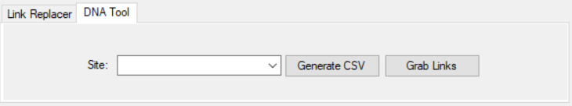

The DNA Tool is a specific tool for generating a csv file to be read by the Asset Finder which contains every asset that shows up in the PDFs. It can also generate a csv file containing every hyperlink that shows up in the PDFs.

### Asset CSV

To generate a csv file to be read by the Asset Finder, select the appropriate site and click “Generate CSV”. The asset csv file should be in the following format:

|  |  |  |  |  |
| --- | --- | --- | --- | --- |
| Asset Number | Asset Name | PDF Link | Equipment Number | PDF Name |

However, the tool currently is incapable of getting the asset name and equipment numbers. As such, those fields are left blank, and the csv generated by the tool is in the form of:

assetNum,,PDFLink,,PDFName

The asset name and equipment numbers (where applicable) could be found by later running a VLOOKUP function in Excel using the asset list. An example of a line in the completed csv file is:

R6760, Colour Holding Tank 1, http://operations.connect.na.local/support/Reliability/IKOMadoc/PlantAs

setDocs/Holding_Tanks.pdf, C-H-01, Holding_Tanks.pdf

**Notes:**

1. As the PDF link is site-dependent, it is important to choose the appropriate site before generating the csv. If the files are from SharePoint, the site will be automatically updated.
2. The equipment number section is not applicable to most sites. In such cases, column D of the respective csv should remain blank.

The tool will then output a csv file titled as the selected site ID at the specified output folder.

The tool works by searching for blue boxes. More specifically, hyperlinks which contain the string “assetnum”, such as:

http://nscandacmaxapp1.na.iko/maximo/webclient/login/login.jsp?mobile=false&event=loadapp&value=createsr&additionalevent=insert&additionaleventvalue=assetnum=S6303

As such, if there is an error in the link itself, the program will be unable to catch it, even if the DNA seems to be perfectly fine. This is why it’s important to search for files the tool had troubles reading.

### Link Grabber

To generate a csv file of every hyperlink that shows up in the PDFs, select the appropriate site and click “Grab Links”. The link csv file should be in the following format:

|  |  |
| --- | --- |
| Hyperlink | PDF Name |

The tool works by searching for annotations in the PDF which are Uniform Resource Identifiers (URIs) and checking if the first 4 characters of the URI matches “http”. As such, if there was an error in entering the link when creating the PDF (such as entering “hhttp” or “vttp”), the tool will not recognize it as a hyperlink and it will be skipped. The tool will output the PDF name and the number of links found in that PDF to the text log.

## Maintenance

As new sites are added or old sites get changes, their information can be updated in the “Sites.csv” file included in the program folder. The file is required for the program to run. The format for a site is:

|  |  |  |
| --- | --- | --- |
| Site Name | Site ID | SharePoint Link |

An example of an entry is:

Calgary,BA,http://operations.connect.na.local/support/Reliability/IKOCalgary/CalgaryAssetDocuments

**Note**: It is important that the SharePoint Link does not contain the final “/”, as it would mess up the program.

The program is available at: [LinkReplacer and DNATool](LinkReplacer%20and%20DNATool)

Source code and previous versions (might be outdated) available at: LinkReplacer, or on GitHub (best bet for the most current version): [GitHub Repository](https://github.com/TanksRUs/LinkReplacer-DNATool)

## Instructions for Use

You should fully read through the entire SOP before getting to this point. This procedure allows for **batch changing of links** while **preserving the unique asset numbers** of each link

1. Select the appropriate file, folder or site (if all links of a particular type are being changed for a given site).
2. Create or choose a local folder to store the files where links have been changed. **It is better to do everything offline and then upload to SharePoint to avoid messing up all documents.**

**If you a changing a link where the unique asset number is not at the end of the link, follow all of the following steps, else skip steps 6 to 9**.

1. Copy the front part of the link that is **common to all links of the same type being replaced** and paste this in the *String to Find* section of the tools.
2. Copy the **common part of the new link** in the *Replace* section and click the *Find and Replace* then click the *Add/Replace* button.
3. The files with the changed link will now be found in the local folder that you created.
4. The new link (common part as used in step 4) will now be used in the string to replace location as the old common link would have already been replaced with this link.
5. Click *add to end* and paste the common part of the new link being added to end of each link in the *String to add/replace* field.
6. Ensure that you now click *choose local folder/file* to select the location of the file(s) created with the initial link replacement at step 5.
7. Create **another** **new local folder** that the files with the entirely updated links will be stored in and set this as the new output location. This step is being done as **errors will occur if you try to replace the files of the partially changed links in the initial folder.**
8. You can now drag and replace the files with the updated links to the respective location on SharePoint. This step will **update the revision** and **check in the new files** with the updated links. You may need to **do this step in batches** as SharePoint allows for a **maximum of 100 uploads at a time**.